**PIZZA SALES SQL QUERIES REPORT**

KEY PERFORMANCE INDICATORS

1. **Total Revenue**:

SELECT SUM (total_price) AS Total_Revenue FROM pizza_sales;

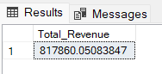

1. **Average Order Value:**

SELECT (SUM (total_price) / COUNT (DISTINCT order_id)) AS Avg_order_Value FROM pizza_sales;

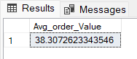

1. **Total Pizzas Sold:**

SELECT SUM (quantity) AS Total_pizza_sold FROM pizza_sales;

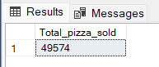

1. **Total Orders:**

SELECT COUNT (DISTINCT order_id) AS Total_Orders FROM pizza_sales;

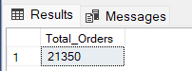

1. **Average Pizzas Per Order:**

SELECT CAST (CAST (SUM (quantity) AS DECIMAL (10,2)) /

CAST (COUNT (DISTINCT order_id) AS DECIMAL (10,2)) AS DECIMAL (10,2))

AS Avg_Pizzas_per_order

FROM pizza_sales;

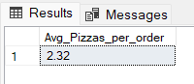

DAILY TREND FOR TOTAL WORKERS

SELECT DATENAME (DW, order_date) AS order_day, COUNT (DISTINCT order_id) AS total_orders

FROM pizza_sales GROUP BY DATENAME (DW, order_date);

***Output:***

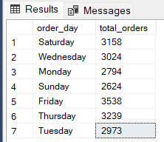

MONTHLY TREND FOR ORDERS

SELECT DATENAME (MONTH, order_date) AS Month_Name, COUNT (DISTINCT order_id) AS Total_Orders FROM pizza_sales GROUP BY DATENAME (MONTH, order_date);

***Output:***

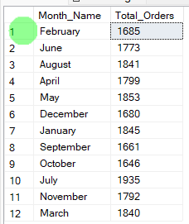

% OF SALES BY PIZZA CATEGORY

SELECT pizza_category, CAST (SUM (total_price) AS DECIMAL (10,2)) as total_revenue, CAST (SUM (total_price) * 100 / (SELECT SUM (total_price) from pizza_sales) AS DECIMAL (10,2)) AS PCT

FROM pizza_sales GROUP BY pizza_category;

***Output:***

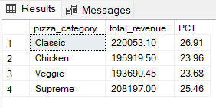

% OF SALES BY PIZZA SIZE

SELECT pizza_size, CAST (SUM (total_price) AS DECIMAL (10,2)) as total_revenue,

CAST (SUM (total_price) * 100 / (SELECT SUM (total_price) from pizza_sales) AS DECIMAL (10,2)) AS PCT

FROM pizza_sales GROUP BY pizza_size

ORDER BY pizza_size;

***Output:***

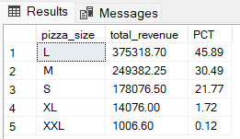

TOTAL PIZZAS SOLD BY PIZZA CATEGORY

SELECT pizza_category, SUM (quantity) as Total_Quantity_Sold

FROM pizza_sales WHERE MONTH (order_date) = 2

GROUP BY pizza_category

ORDER BY Total_Quantity_Sold DESC;

***Output:***

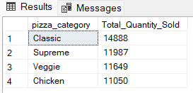

TOP 5 PIZZAS BY REVENUE

SELECT Top 5 pizza_name, SUM(total_price) AS Total_Revenue

FROM pizza_sales GROUP BY pizza_name

ORDER BY Total_Revenue DESC;

***Output:***

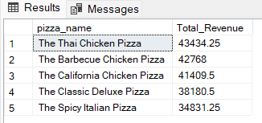

BOTTOM 5 PIZZAS BY REVENUE

SELECT Top 5 pizza_name, SUM (total_price) AS Total_Revenue

FROM pizza_sales

GROUP BY pizza_name

ORDER BY Total_Revenue ASC;

***Output:***

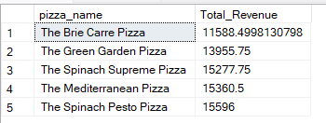

TOP 5 PIZZAS BY QUANTITY

SELECT Top 5 pizza_name, SUM (quantity) AS Total_Pizza_Sold

FROM pizza_sales

GROUP BY pizza_name

ORDER BY Total_Pizza_Sold DESC;

***Output:***

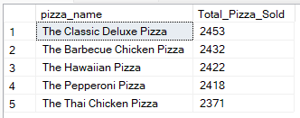

BOTTOM 5 PIZZAS BY QUANTITY

SELECT TOP 5 pizza_name, SUM (quantity) AS Total_Pizza_Sold FROM pizza_sales

GROUP BY pizza_name ORDER BY Total_Pizza_Sold ASC;

***Output:***

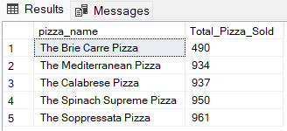

TOP 5 PIZZAS BY TOTAL ORDERS

SELECT Top 5 pizza_name, COUNT (DISTINCT order_id) AS Total_Orders

FROM pizza_sales

GROUP BY pizza_name

ORDER BY Total_Orders DESC;

***Output:***

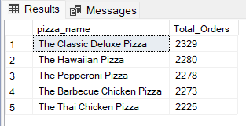

BOTTOM 5 PIZZAS BY TOTAL ORDERS

SELECT Top 5 pizza_name, COUNT (DISTINCT order_id) AS Total_Orders

FROM pizza_sales

GROUP BY pizza_name

ORDER BY Total_Orders ASC;

***Output:***

